1. The software development life cycle is often shown in graphical form as shown below:

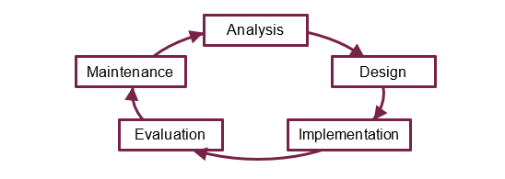

(a) Why is it shown as a never-ending cycle? [1]

Because maintenance will never end as there is always stuff that breaks.

(b) Fill in the table to show at which stage each of the following steps occurs.   
The first one has been done for you. [5]

|  |  |  |
| --- | --- | --- |
|  |  | **Stage** |
| 1 | The systems analyst interviews people who will use  the software | Analysis |
| 2 | A description of how the data will be processed is drawn up | Design |
| 3 | User and technical documentation is written | implementation |
| 4 | The user tests the system to make sure it does what it is supposed to do | evaluation |
| 5 | Users fill in questionnaires about what they think the problems are with the current way of doing things | analysis |
| 6 | A test plan is drawn up | design |
| 7 | The software is modified to allow a new method of  inputting data | maintenance |
| 8 | The systems analyst observes how the current system works | evaluation |
| 9 | A new menu item is added to the software because of a change in user requirements over time | maintenance |
| 10 | A programming language or software package to be used for implementing the system is chosen | design |
| 11 | The software is coded and tested | implementation |

2 Mark each of the following statements as TRUE or FALSE. [4]

|  |  |  |
| --- | --- | --- |
|  | **Statement** | **True or false?** |
| 1 | The Waterfall software development life cycle uses prototyping | True |
| 2 | A prototype can either be a throw-away or can be refined through several cycles | False |
| 3 | The Spiral model is suitable for small projects | True |
| 4 | A lifecycle model which uses prototypes is more likely to result in what the customer actually wants | True |
| 5 | Pseudocode and flowcharts are used in the Analysis stage of the software development life cycle | False |
| 6 | A model using prototypes is time-consuming because of the process of getting feedback, and is therefore more costly than other types of model | true |
| 7 | The Agile model is developed in rapid incremental cycles, with each version building on the previous one | True |
| 8 | In the Agile model, customers, developers and testers frequently interact with each other | True |

3. A software company, TOPS, has been asked to build a large complex website for a rapidly expanding company, Acme Electronics Ltd. Acme feels they have outgrown their current website and they want to have a completely new website built, with a new design and much more functionality. TOPS has been recommended to them because it has a team of very experienced designers and programmers.

Describe the **waterfall** and **spiral** software development models. Discuss the advantages and disadvantages of each.

State which you would recommend for this project, giving reasons for your answer.

In this question you will be marked on your ability to use good English, to organise information clearly and to use specialist vocabulary where appropriate. [10]

Total 20 marks